MUSIC STORE DATA ANALYSIS

**FINAL PROJECT FOR SQL MODULE**

**By SAUDAMINI DESHMUKH**

**DISCRIPTION:**

The Music Store Data Analysis System is structured to efficiently manage and analyze various aspects of a music retail business. Utilizing a relational database with 11 interconnected tables, this system captures and organizes data related to albums, artists, customers, employees, genres, invoices, and more. The goal is to enhance decision-making and operational efficiency within the store.

**Following database schema is designed to function as a backend storage database for an Music Store Data Analysis System.**

**By storing information in a relational database, all tasks related to the daily functioning of the Music Store can be performed easily and more efficiently. Some of the benefits of using this system to store data over traditional paper methods or unstructured databases are as follows**:

1. **Efficient Data Management**: Adding, updating, and modifying the music catalog (e.g., tracks, albums, and artists) is simple and fast.
2. **Customer Insights**: Storing customer information, including purchase history and preferences, enables better customer service and more personalized offers.
3. **Data Analytics**: The Relational Database Management System (RDBMS) enables rich data analysis and reporting, such as identifying top-selling tracks, customer purchase trends, and artist performance, to assist in making informed business decisions.

**This database contains 9 tables:**

1. ALBUM
2. ARTIST
3. CUSTOMER
4. EMPLOYEE
5. GENERE
6. INVOICE
7. INVOICE_LINE
8. MEDIA_TYPE
9. PLAYLIST
10. PLAYLIST_TRACK
11. TRACK

**How these tables/entities are related to each other is shown pictorially on next page through ER diagram, i.e., Entity Relationship Diagram.**

1. **ER DIAGRAM:**

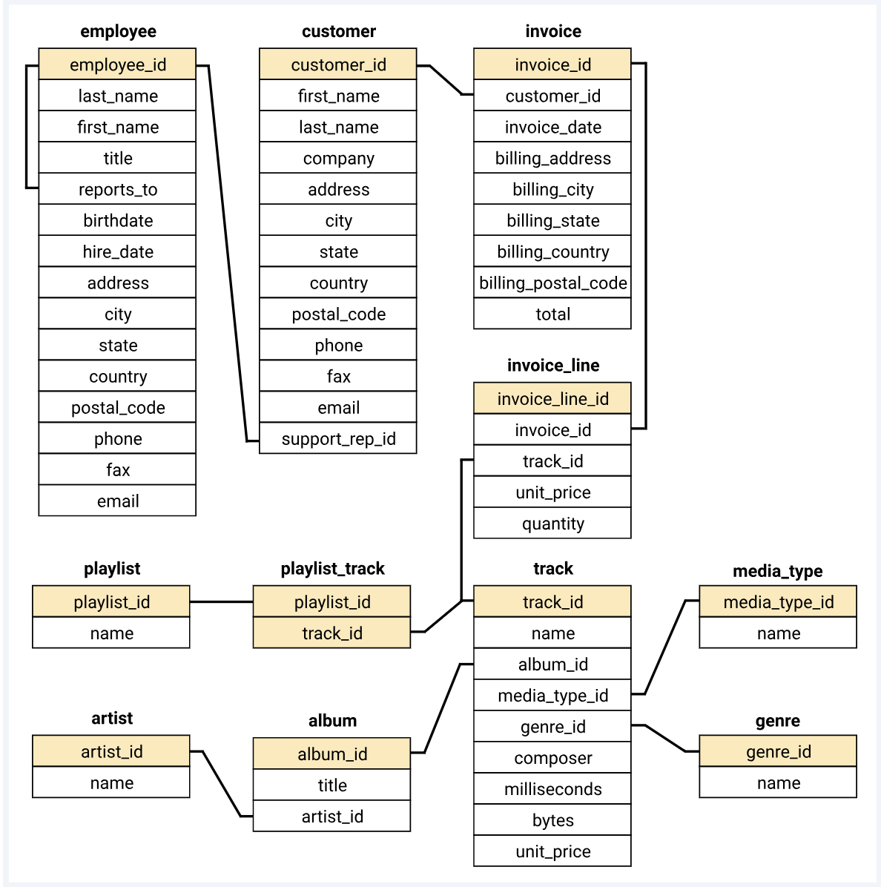

1. **TABLE AND DESCRIPTION:**

**a.Customer**

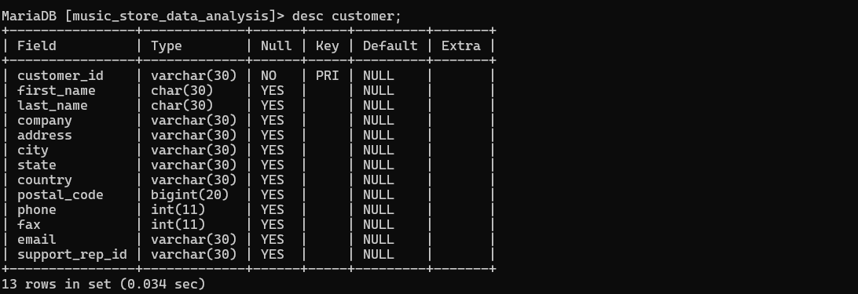

**b.Employee**

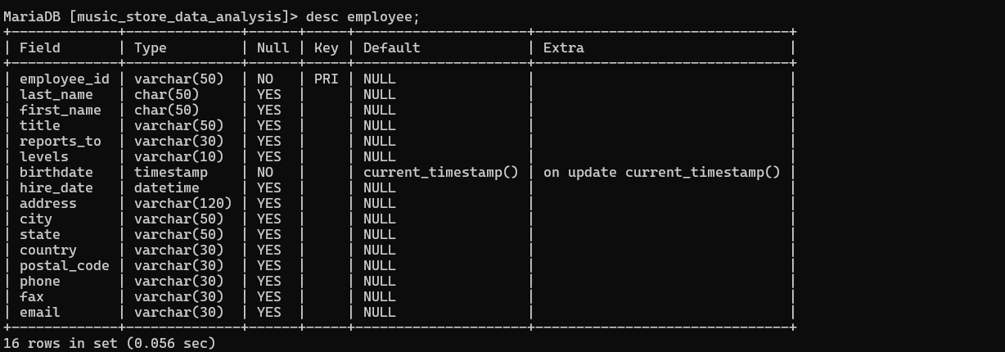

**c.Artist**

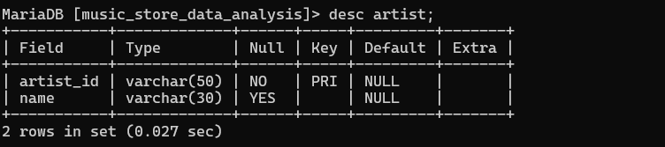

**d.Album**

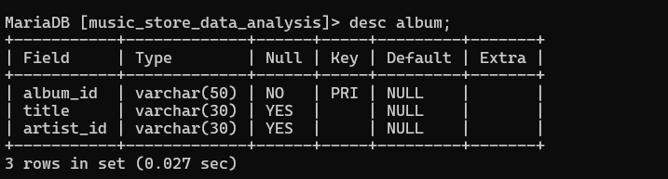

**e.Genre**

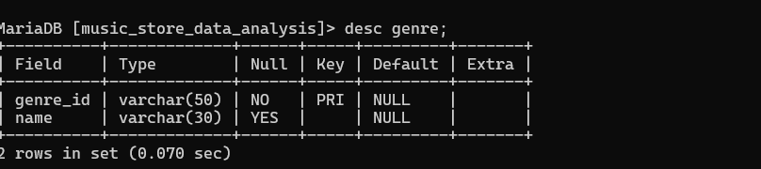

**f.Invoice**

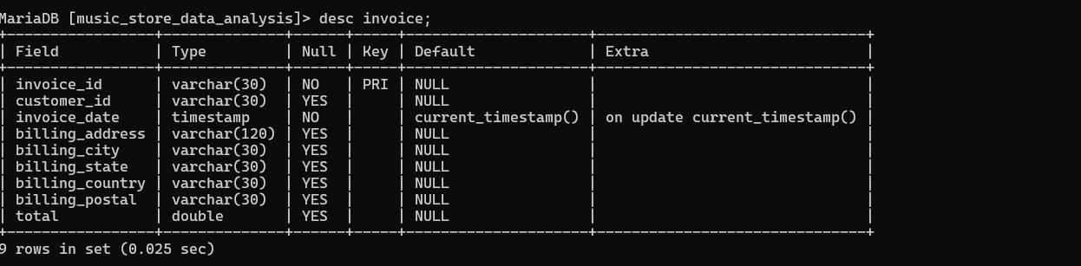

**g.Invoice_line**

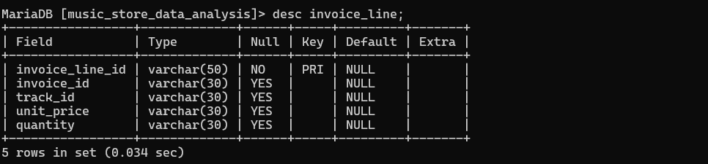

**h.Media_type**

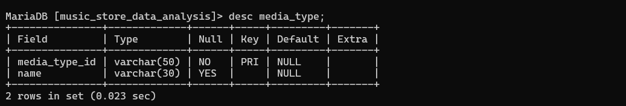

**i.Playlist**

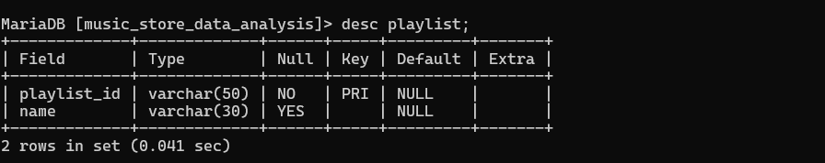

**j.Playlist_track**

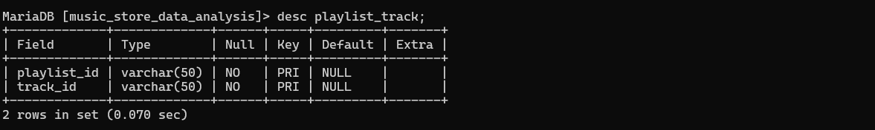

**k.Track**

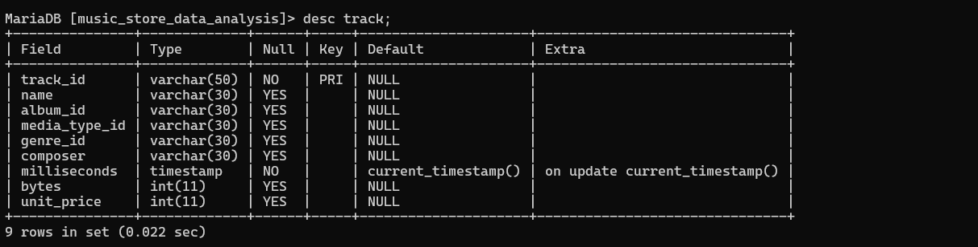

1. **COMMANDS:**

**create database:**

*create database Music_store_data_analysis;*

**use music_store_data_analysis;**

**CREATE TABLE employee(**

-> *employee_id VARCHAR(50) PRIMARY KEY,*

*-> last_name CHAR(50),*

*-> first_name CHAR(50),*

*-> title VARCHAR(50),*

*-> reports_to VARCHAR(30),*

*-> levels VARCHAR(10),*

*-> birthdate TIMESTAMP,*

*-> hire_date datetime,*

*-> address VARCHAR(120),*

*-> city VARCHAR(50),*

*-> state VARCHAR(50),*

*-> country VARCHAR(30),*

*-> postal_code VARCHAR(30),*

*-> phone VARCHAR(30),*

*-> fax VARCHAR(30),*

*-> email VARCHAR(30));*

**CREATE TABLE customer**(

-> customer_id VARCHAR(30) PRIMARY KEY,

-> first_name CHAR(30),

-> last_name CHAR(30),

-> company VARCHAR(30),

-> address VARCHAR(30),

-> city VARCHAR(30),

-> state VARCHAR(30),

-> country VARCHAR(30),

-> postal_code INT8,

-> phone INT,

-> fax INT,

-> email VARCHAR(30),

-> support_rep_id VARCHAR(30));

**CREATE TABLE invoice(**

-> invoice_id VARCHAR(30) PRIMARY KEY,

-> customer_id VARCHAR(30),

-> invoice_date TIMESTAMP,

-> billing_address VARCHAR(120),

-> billing_city VARCHAR(30),

-> billing_state VARCHAR(30),

-> billing_country VARCHAR(30),

-> billing_postal VARCHAR(30),

-> total FLOAT8);

**CREATE TABLE invoice_line(**

-> invoice_line_id VARCHAR(50) PRIMARY KEY,

-> invoice_id VARCHAR(30),

-> track_id VARCHAR(30),

-> unit_price VARCHAR(30),

-> quantity VARCHAR(30));

**CREATE TABLE track(**

-> track_id VARCHAR(50) PRIMARY KEY,

-> name VARCHAR(30),

-> album_id VARCHAR(30),

-> media_type_id VARCHAR(30),

-> genre_id VARCHAR(30),

-> composer VARCHAR(30),

-> milliseconds TIMESTAMP,

-> bytes INT,

-> unit_price INT);

**CREATE TABLE playlist(**

-> playlist_id VARCHAR(50) PRIMARY KEY,

-> name VARCHAR(30));

**CREATE TABLE playlist_track(**

-> playlist_id VARCHAR(50),

-> track_id VARCHAR(50) );

alter table playlist_track add primary key(playlist_id,track_id);

**CREATE TABLE artist(**

-> artist_id VARCHAR(50) PRIMARY KEY,

-> name VARCHAR(30));

**CREATE TABLE album**(

-> album_id VARCHAR(50) PRIMARY KEY,

-> title VARCHAR(30),

-> artist_id VARCHAR(30));

**POPULATE EMPLOYEE TABLE:**

**insert into employee values**(1,'Adams','Andrew','General Manager',9,'L6','18-02-1962 00:00','14-08-2016 00:00','11120JasperNW','Edmonton','AB','Canada','T5K 2N1','+1 (780) 428-9482','+1 (780) 428-3457','andrew@chinookcorp.com'),

(2,'Edwards','Nancy','Sales Manager',1,'L4','08-12-1958 00:00','01-05-2016 00:00','825 8 Ave SW','Calgary','AB','Canada','T2P 2T3','+1 (403) 262-3443','+1 (403) 262-3322','nancy@chinookcorp.com'),

(3,'Peacock','Jane','Sales Support Agent',2,'L1','29-08-1973 00:00','01-04-2017 00:00','1111 6 Ave SW','Calgary','AB','Canada','T2P 5M5','+1 (403) 262-3443','+1 (403) 262-6712','jane@chinookcorp.com'),

( 4,'Park','Margaret','Sales Support Agent',2,'L1','19-09-1947 00:00','03-05-2017 00:00','683 10 Street SW','Calgary','AB','Canada','T2P 5G3','+1 (403) 263-4423','+1 (403) 263-4289','margaret@chinookcorp.com'),

( 5,'Johnson','Steve','Sales Support Agent',2,'L1','03-03-1965 00:00','17-10-2017 00:00','727B 41 Ave','Calgary','AB','Canada','T3B 1Y7','1 (780) 836-9987','1 (780) 836-9543','steve@chinookcorp.com'),

( 6,'Mitchell','Michael','IT Manager',1,'L3','01-07-1973 00:00','17-10-2016 00:00','5827 Bowness Road NW','Calgary','AB','Canada','T3B 0C5','+1 (403) 246-9887','+1 (403) 246-9899','michael@chinookcorp.com'),

(7,'King','Robert','IT Staff',6,'L2','29-05-1970 00:00','02-01-2017 00:00','590 Columbia Boulevard West','Lethbridge','AB','Canada','T1K 5N8','+1 (403) 456-9986','+1 (403) 456-8485','robert@chinookcorp.com'),

( 8,'Callahan','Laura','IT Staff',6,'L2','09-01-1968 00:00','04-03-2017 00:00','923 7 ST NW','Lethbridge','AB','Canada','T1H 1Y8','+1 (403) 467-3351','+1 (403) 467-8772','laura@chinookcorp.com');

**POPULATE CUSTOMER TABLE:**

**insert into customer values**(1,'Luís','Gonçalves','Embraer - Empresa Brasileira de Aeronáutica S.A.',"Av. Brigadeiro Faria Lima, 2170",'São JosCampos','SP','Brazil','12227-000','+55 (12) 3923-5555','+55 (12) 3923-5566','luisg@embraer.com.br',3) (2,'Leonie','Köhler','' ,'Theodor-Heuss-Straße 34','Stuttgart','','Germany','70174','+49 0711 2842222','' ,'leonekohler@surfeu.de',5);

Insert into customer(customer_id,first_name,last_name,address,city,state,country,postal_code,phone,email,support_rep_id)values(3,'François','Tremblay','1498 rue Bélanger','Montréal','QC','Canada','H2G 1A7','+1 (514) 721-4711','ftremblay@gmail.com',3);

insert into customer values(5,'František','Wichterlová','JetBrains s.r.o.','Klanova 9/506','Prague','SP','Czech Republic',14700,+42041725555,+420241725555,'frantisekw@jetbrains.com',4)

insert into customer(customer_id,first_name,last_name,address,city,country,postal_code,phone,email,support_rep_id) values(6,'Helena','Holý','Rilská 3174/6','Prague','Czech Republic',14300,+420241770449,'hholy@gmail.com',5);

insert into customer(customer_id,first_name,last_name,address,city,country,postal_code,phone,email,support_rep_id) values(7,'Astrid','Gruber',"Rotenturmstraße 4, 1010 Innere Stadt",'Vienne','Austria',1010,+43015134505,'astrid.gruber@apple.at',5);

insert into customer(customer_id,first_name,last_name,address,city,country,postal_code,phone,email,support_rep_id) values(8,'Daan','Peeters','Grétrystraat 63','Brussels','Belgium',1000,+32022190303,'daan_peeters@apple.be',4);

insert into customer(customer_id,first_name,last_name,address,city,country,postal_code,phone,email,support_rep_id) values(9,'Kara','Nielsen','Sønder Boulevard 51','Copenhagen','Denmark',1720,+45333319991,'kara.nielsen@jubii.dk',4);

insert into customer values(11,'Alexandre','Rocha','Banco do Brasil S.A.',"Av. Paulista, 2022",'São Paulo','SP','Brazil',01310-200,+5513055-3278,+55113055-8131,'alero@uol.com.br',5);

insert into customer values(12,'Roberto','Almeida','Riotur',"Praça Pio X, 119",'Rio de Janeiro','RJ','Bra'zil',20040020,+552122717000,+52122717070,'roberto.almeida@riotur.gov.br',3);

insert into customer values(12,'Mark','Philips','Telus','8210 111 ST NW','Edmonton','AB','Canada','T6G 2C7',+1780434-4554,+1780434-5565,'mphilips12@shaw.ca',5);

**POPULATE ALBUM TABLE:**

**insert into album values**(1,'For Those About To Rock We Salute You',1),(2,'Balls to the Wall',2),(3,'Restless and Wild',2),(4,'Let There Be Rock',1),(5,'Big Ones',3),(6,'Jagged Little Pill',4),(7,'Facelift',5),(8,'Warner 25 Anos',6),(9,'Plays Metallica By Four Cellos',7),(10,'Audioslave',8), (12,'BackBeat Soundtrack',9),(13,'The Best Of Billy Cobham',10),(14,'Alcohol Fueled BrewtalityLive! [Disc 1]',11),(15,'Alcohol Fueled Brewtality Live! [Disc 2]',11),(16,'Black Sabbath',12),(17,'Black Sabbath Vol. 4 (Remaster)',12),(18,'Body Count',13),(19,'Chemical Wedding',14),(20,'The Best Of Buddy Guy - The Millenium Collection',15),( 21,'Prenda Minha',16),(22,'Sozinho Remix Ao Vivo',16),(23,'Minha Historia',17),( 24,'Afrociberdelia',18),(25,'Da Lama Ao Caos',18),( 26,'Acústico MTV [live]',19),(27,'Cidade Negra - Hits',19),( 28,'Na Pista',20),( 29,'Axé Bahia 2001',21),( 30,'BBC Sessions [Disc 1] [live]',22);

**POPULATE ARTIST TABLE:**

**insert into artist values**(1,'AC/DC'),(2,'Accept'),(3,'Aerosmith'),(4,'Alanis Morissette'),(5,'Alice In Chains'),(6,'Antônio Carlos Jobim'),(7,'Apocalyptica'),(8,'Audioslave'),(9,'BackBeat'),(10,'Billy Cobham'),(11,'Black Label Society'),(12,'Black Sabbath'),(13,'Body Count'),(14,'Bruce Dickinson'),(15,'Buddy Guy'), (16,'Caetano Veloso'),(17,'Chico Buarque'),(18,'Chico Science & Nação Zumbi'),(19,'Cidade Negra'),(20,'Cláudio Zoli'),(21,'Various Artists'),(22,'Led Zeppelin'),(23,'Frank Zappa & Captain Beefheart'),(24,'Marcos Valle'),(25,'Milton Nascimento & Bebeto');

**POPULATE GENERE TABLE:**

**insert into genre values(**1,'Rock'),(2,'Jazz'),( 3,'Metal'),(4,'Alternative & Punk'),( 5,'Rock And Roll'),(6,'Blues'),(7,'Latin'),(8,'Reggae'),(9,'Pop'),(10,'Soundtrack'),(11,'Bossa Nova'),(12,'Easy Listening'),(13,'Heavy Metal'),( 14,'R&B/Soul'),(15,'Electronica/Dance'),(16,'World'),(17,'Hip Hop/Rap'),(18,'Science Fiction'),(19,'TV Shows'),(20,'Sci Fi & Fantasy'),(21,'Drama'),( 22,'Comedy'),(23,'Alternative'),(24,'Classical'),(25,'opera');

**POPULATE INVOICE_LINE TABLE:**

**insert into invoice_line values**(2,1,1159,0.99,1),(3,1,1160,0.99,1),(4,1,1161,0.99,1),( 5,1,1162,0.99,1),(6,1,1163,0.99,1),(7,1,1164,0.99,1),(8,1,1165,0.99,1),(9,1,1166,0.99,1),(10,1,1167,0.99,1),(11,1,1168,0.99,1),(12,1,1169,0.99,1),(13,1,1170,0.99,1),(14,1,1171,0.99,1),(15,1,1172,0.99,1),(16,1,1173,0.99,1),( 17,2,3476,0.99,1),(18,2,482,0.99,1),( 19,2,2701,0.99,1), (20,2,1641,0.99,1),(21,2,1119,0.99,1),(22,2,2324,0.99,1),(23,2,201,0.99,1),(24,2,819,0.99,1),(25,2,392,0.99,1),( 26,2,2651,0.99,1),(27,3,2516,0.99,1),( 28,3,2646,0.99,1),(29,4,3448,0.99,1),(30,4,2560,0.99,1),( 31,4,3336,0.99,1),( 32,4,829,0.99,1),( 33,4,1872,0.99,1),(34,4,748,0.99,1),(35,4,1778,0.99,1),(36,4,2514,0.99,1),( 37,5,1986,0.99,1),(38,5,1987,0.99,1),(39,5,1988,0.99,1),(40,5,1989,0.99,1),

(41,5,1990,0.99,1),(42,5,1991,0.99,1),(43,5,1992,0.99,1),(44,5,1993,0.99,1),(45,5,1994,0.99,1),(46,5,1995,0.99,1),( 47,5,1996,0.99,1),(48,5,1997,0.99,1),(49,5,1998,0.99,1),(50,5,1999,0.99,1);

**POPULATE INVOICE TABLE:**

**insert into invoice values**(1,18,'2017-01-03 00:00:00','627 Broadway','New York','NY','USA',10012-2612,15.84),(2,30,'2017-01-03 00:00:00','230 Elgin Street','Ottawa','ON','Canada','K2P 1L7',9.9),(3,40,'2017-01-05 00:00:00',"8, Rue Hanovre",'Paris','None','France',75002,1.98), (4,18,'2017-01-06 00:00:00','627 Broadway','New York','NY','USA',10012-2612,7.92),(5,27,'2017-01-07 00:00:00','1033 N Park Ave','Tucson','AZ','USA',85719,16.83),(6,31,'2017-01-10 00:00:00','194A Chain Lake Drive','Halifax','NS','Canada','B3S 1C5',1.98),(7,49,'2017-01-12 00:00:00','Ordynacka 10','Warsaw','None','Poland',00-358,10.89),(8,59,'2017-01-13 00:00:00',"3,Raj Bhavan Road",'Bangalore','None','India',560001,9.9), (9,18,'2017-01-18 00:00:00','627 Broadway','New York','NY','USA',10012-2612,8.91),(10,31,'2017-01-18 00:00:00','194A Chain Lake Drive','Halifax','NS','Canada','B3S 1C5',1.98);

insert into invoice values(11,38,'2017-01-20 00:00:00','Barbarossastraße 19','Berlin','None','Germany',10779,10.89),(12,42,'2017-01-21 00:00:00',"9, Place Louis Barthou",'Bordeaux','None','France',33000,3.96),(13,35,'2017-01-22 00:00:00',"Rua dos Campeões Europeus de Viena, 4350",'Porto','None','Portugal','None',0.99),(14,25,'2017-01-23 00:00:00','319 N. Frances Street','Madison','WI','USA',53703,0.99),(15,44,'2017-01-25 00:00:00','Porthaninkatu 9','Helsinki','None','Finland',00530,3.96),(16,1,'2017-01-26 00:00:00',"Av. Brigadeiro Faria Lima, 2170",'São José dos Campos','SP','Brazil',12227-000,8.91),(17,20,'2017-01-28 00:00:00','541 Del Medio Avenue','Mountain View','CA','USA',94040-111,10.89),(18,24,'2017-02-02 00:00:00','162 E Superior Street','Chicago','IL','USA',60611,4.95),(19,10,'2017-02-06 00:00:00',"Rua Dr. Falcão Filho, 155",'São Paulo','SP','Brazil',01007-010,6.93),(20,43,'2017-02-06 00:00:00',"68, Rue Jouvence",'Dijon','None','France',21000,9.9);

**POPULATE MEDIA_TYPE TABLE:**

**insert into media_type values**(1,'MPEG audio file'),(2,'Protected AAC audio file'),(3,'Protected MPEG-4 video file'),(4,'Purchased AAC audio file'),(5,'AAC audio file');

**POPULATE PLAYLIST TABLE:**

**insert into playlist values**(1,'Music'),( 2,'Movies'),( 3,'TV Shows'),( 4,'Audiobooks'),(5,'90’s Music'),(6,'Audiobooks'),( 7,'Movies'),( 8,'Music'),( 9,'Music Videos'),(10,'TV Shows'),( 11,'Brazilian Music'),( 12,'Classical'),(13,'Classical 101 - Deep Cuts'),( 14,'Classical101 - Next Steps'),(15,'Classical 101 - The Basics'),(16,'Grunge'),(17,'Heavy Metal Classic'),( 18,'On-The-Go 1');

**POPULATE PLAYLIST_TRACK TABLE:**

**Insert into playlist_track values** (1,3378),(1,3379),(1,3380),(1,3381),(1,3382),(1,3383),(1,3384),(1,3385),(1,3386),(1,3387),(1,3388),(1,3365),(1,3366),(1,3367),(1,3368),(1,3369),(1,3370),(1,3371),(1,3372),(1,3373),(1,3374),(1,99),(1,100),(1,101),(1,102),(1,103),(1,104),(1,105),(1,106),(1,107),(1,108),(1,109),(1,110),(1,166),(1,167),(1,168),(1,169),(1,170),(1,171),(1,172),(1,173),(1,174),(1,175),(1,176),(1,177),(1,178),(1,179),(1,180),(1,181),(1,182),(1,2591),(1,2592),(1,2593),(1,2594),(1,2595),(1,2596),(1,2597),(1,2598),(1,2599),(1,2600),(1,2601),(1,2602),(1,2603),(1,2604),(1,2605),(1,2606),(1,2607),(1,2608),(1,923),(1,924),(1,925),(1,926),(1,927),(1,928),(1,929),(1,930),(1,931),(1,932),(1,933),(1,934),(1,935),(1,936),(1,937),(1,938),(1,939),(1,940),(1,941),(1,942),(1,943),(1,944),(1,945),(1,946),(1,947),(1,948),(1,964),(1,965),(1,966),(1,967),(1,968),(1,969),(1,970),(1,971),(1,972),(1,973),(1,974),(1,1009),(1,1010),(1,1011),(1,1012),(1,1013),(1,1014),(1,1015),(1,1016),(1,1017),(1,1018),(1,1019),(1,1133),(1,1134),(1,1135),(1,1136),(1,1137),(1,1138),(1,1139),(1,1140),(1,1141),(1,1142),(1,1143),(1,1144),(1,1145),(1,468),(1,469),(1,470),(1,471),(1,472),(1,473),(1,474),(1,475),(1,476),(1,477),(1,478),(1,479),(1,480),(1,481),(1,482),(1,483),(1,484),(1,485),(1,486),(1,487),(1,488),(1,1466),(1,1467),(1,1468),(1,1469),(1,1470),(1,1471),(1,1472),(1,1473),(1,1474),(1,1475),(1,1476),(1,1477),(1,1478),(1,529),(1,530),(1,531),(1,532),(1,533),(1,534),(1,535),(1,536),(1,537),(1,538),(1,539),(1,540),(1,541),(1,542),(1,2165),(1,2166),(1,2167),(1,2168),(1,2169),(1,2170),(1,2171),(1,2172),(1,2173),(1,2174),(1,2175),(1,2176),(1,2177),(1,2318),(1,2319),(1,2320),(1,2321),(1,2322),(1,2323),(1,2324),(1,2325),(1,2326),(1,2327),(1,2328),(1,2329),(1,2330);

**POPULATE TRACK TABLE:**

**insert into track values**(1,'For Those About To Rock (We Salute You)',1,1,1,"Angus Young, Malcolm Young, Brian Johnson",343719,11170334,0.99);

insert into track(track_id,name,album_id,media_type_id,genre_id,milliseconds,bytes,unit_price) values(2,'Balls to the Wall',2,2,1,342562,5510424,0.99);

insert into track values(3,'Fast As a Shark',3,2,1,"F. Baltes, S. Kaufman, U. Dirkscneider & W. Hoffman",230619,3990994,0.99);

insert into track values(4,'Restless and Wild',3,2,1,"F. Baltes, R.A. Smith-Diesel, S. Kaufman, U. Dirkscneider & W. Hoffman",252051,4331779,0.99),(5,'Princess of the Dawn',3,2,1,'Deaffy & R.A. Smith-Diesel',375418,6290521,0.99),(6,'Put The Finger On You',1,1,1,"Angus Young, Malcolm Young, Brian Johnson",205662,6713451,0.99),(7,'Lets Get It Up',1,1,1,"Angus Young, Malcolm Young, Brian Johnson",233926,7636561,0.99),(8,'Inject The Venom',1,1,1,"Angus Young, Malcolm Young, Brian Johnson",210834,6852860,0.99),(9,'Snowballed',1,1,1,"Angus Young, Malcolm Young, Brian Johnson",203102,6599424,0.99), (10,'Evil Walks',1,1,1,"Angus Young, Malcolm Young, Brian Johnson",263497,8611245,0.99),(11,'C.O.D.',1,1,1,"Angus Young, Malcolm Young, Brian Johnson",199836,6566314,0.99),(12,'Breaking The Rules',1,1,1,"Angus Young, Malcolm Young, Brian Johnson",263288,8596840,0.99),(13,'Night Of The Long Knives',1,1,1,"Angus Young, Malcolm Young, Brian Johnson",205688,6706347,0.99), (14,'Spellbound',1,1,1,"Angus Young, Malcolm Young, Brian Johnson",270863,8817038,0.99),(15,'Go Down',4,1,1,'AC/DC',331180,10847611,0.99),(16,'Dog Eat Dog',4,1,1,'AC/DC',215196,7032162,0.99), (17,'Let There Be Rock',4,1,1,'AC/DC',366654,12021261,0.99),(18,'Bad Boy Boogie',4,1,1,'AC/DC',267728,8776140,0.99),(19,'Problem Child',4,1,1,'AC/DC',325041,10617116,0.99),(20,'Overdose',4,1,1,'AC/DC',369319,12066294,0.99);

**Music Store Data Analysis Query**

* **Which countries have the most Invoices?**

SELECT COUNT(*) AS c, billing_country

FROM invoice

GROUP BY billing_country

ORDER BY c DESC

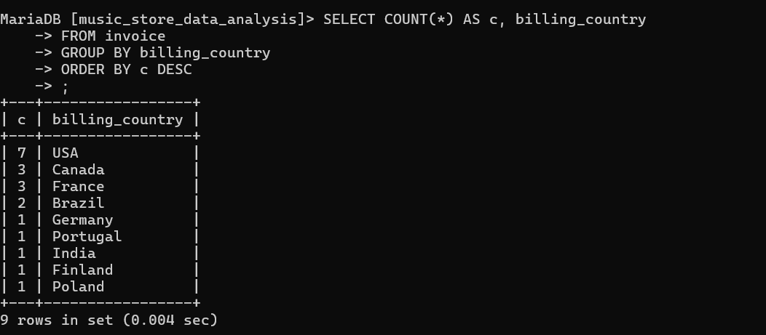

* **Who is the senior most employee based on job title?**

SELECT title, last_name, first_name

FROM employee

ORDER BY levels DESC

LIMIT 1

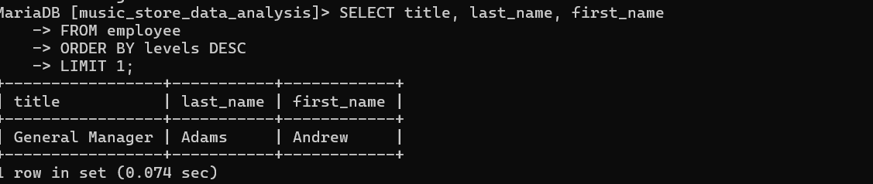

* **What are top 3 values of total invoice?**

SELECT total

FROM invoice

ORDER BY total DESC

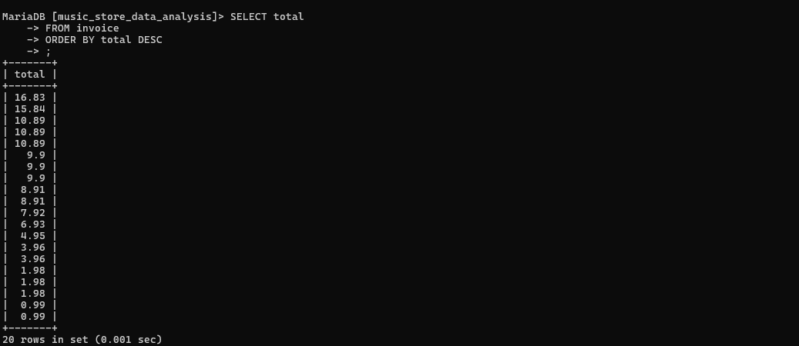

* **Find customers who have made at least one invoice:**

SELECT customer_id, first_name, last_name

FROM customer

WHERE customer_id IN (SELECT DISTINCT customer_id FROM invoice);

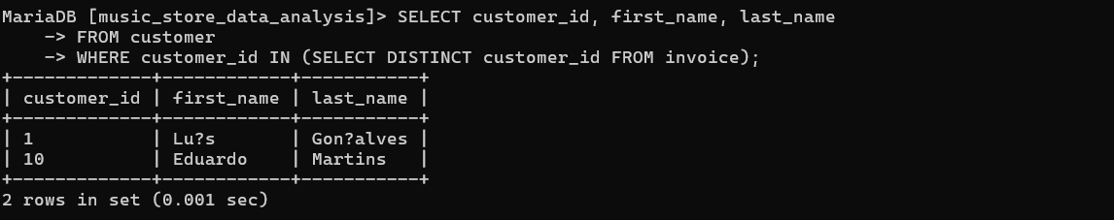

* **Get all invoice lines for a specific invoice (e.g., invoice_id = 5):**

SELECT *

FROM invoice_line

WHERE invoice_id = (SELECT invoice_id FROM invoice WHERE invoice_id = 5);

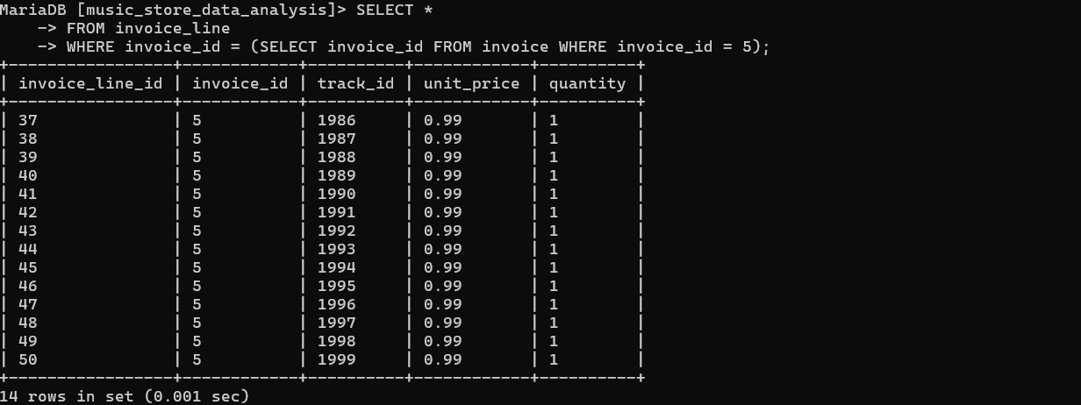

* **List all invoices along with customer details:**

SELECT i.invoice_id, i.invoice_date, c.first_name, c.last_name

FROM invoice i

JOIN customer c ON i.customer_id = c.customer_id;

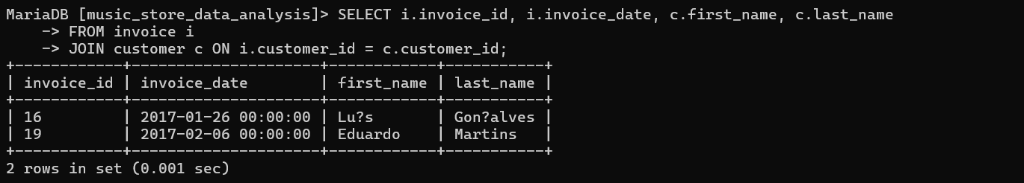

* **Get a list of artists along with their albums:**

SELECT a.artist_id, a.name AS artist_name, al.title AS album_title

FROM artist a

JOIN album al ON a.artist_id = al.artist_id;

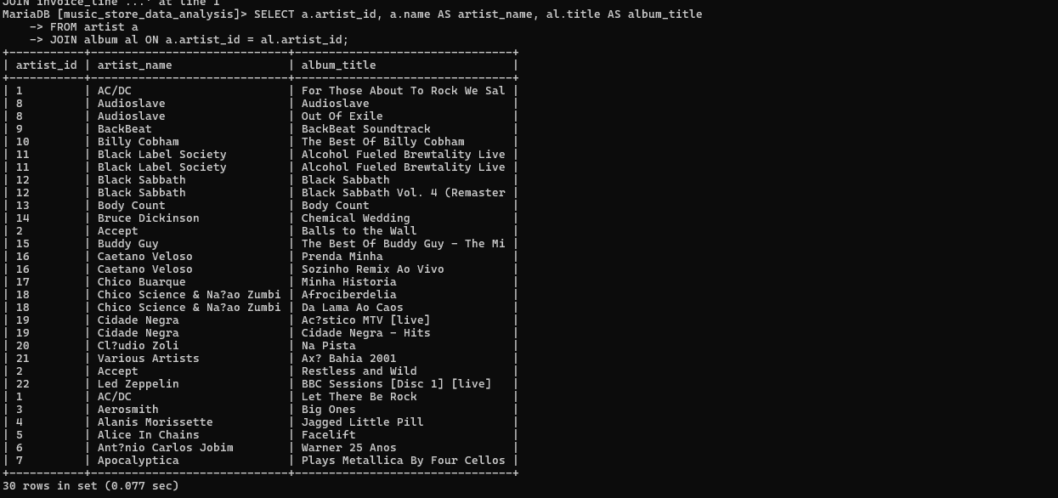

* **List all employees along with their supervisors' names:**

SELECT e.employee_id, e.first_name AS employee_name,

e2.first_name AS supervisor_name

FROM employee e

LEFT JOIN employee e2 ON e.reports_to = e2.employee_id;

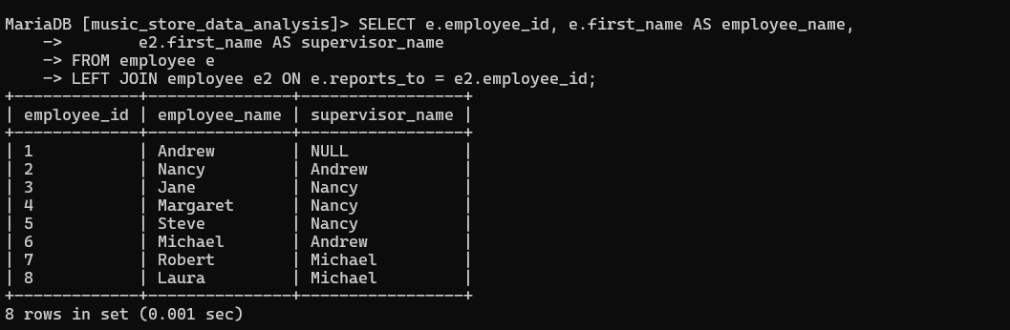

* **Get employees who were born in a specific year or who have a specific title**

SELECT employee_id, first_name, last_name

FROM employee

WHERE employee_id IN (SELECT employee_id FROM employee WHERE EXTRACT(YEAR FROM birthdate) = 0000)

OR title = 'general Manager';

